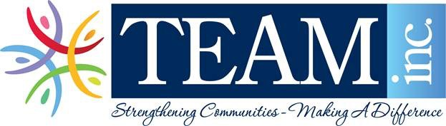

FOR IMMEDIATE RELEASE
Contact: Lisa Savoid, Development & Communications Manager
203-736-5420, ext. 1221
lsavoid@teaminc.org

Intergenerational Fashion Show and Luncheon to Support Meals on Wheels

Who: TEAM, Inc.
When: Saturday, September 15, 2018, 11:00am-2:00pm
Where: Assumption Church, 61 North Cliff Street, Ansonia
What:
TEAM will be hosting its third Intergenerational Fashion Show and Luncheon on August 24, 2019 at Assumption Church Hall, Ansonia. All of the proceeds benefit TEAM’s Meals on Wheels. TEAM is dedicated to addressing senior isolation and hunger – Meals on Wheels delivers nutritious meals, friendly visits and safety checks that support seniors to live nourished lives with independence and dignity. Designed to meet the nutritional and social needs of seniors, TEAM Meals on Wheels is available to homebound persons 60 years and older who reside in Ansonia, Derby, Oxford, Seymour, and Shelton.

This year’s fashion show will include designs for women from J.Jill and Chico’s in Milford. J.Jill is easy, relaxed, inspired style that reflects the confidence of a woman with a rich, full life. J.Jill designs for all sizes—misses, petite, women's and tall. Chico’s has rich colors, bold prints, unique artisanal details, problem-solving styles, and amazing personal stylists. Men’s Designs will include Seccombes Men’s shop who have been in business for 95 years. Seccombe's Men's Shop remains committed to a tradition of offering top quality men’s clothing, fair prices, and exceptional, friendly customer service. Seccombes carry great brands like Ralph Lauren, Calvin Klein, Stephen Geoffrey, Michael Kors, Austin Reed, Enro,
Jockey, Bill's Khakis, Sewell, Stetson, Buestán and more.

Please join us for lunch catered by Waterfront Riverview Cookout, owner Phil Iannaccone, which will include, Gumbo, chicken & beef, Mac & Cheese, vegetables and desert. Then enjoy a Fashion Show with models who are all Valley residents ranging in age from 2 to 98 years old.

We would like to thank our sponsors: Valley Community Foundation, KAFA Group, TNBG Consulting, OEM Controls, Inc., Cohen & Thomas Attorneys at Law and Griffin Health Services.

Tickets:
$25 Adults
$20 Seniors 65+
$5 Children under 10
Purchase tickets by stopping into the TEAM Office at 30 Elizabeth Street in Derby, calling the office at 203-736-5420 or visiting our website, www.teaminc.org

